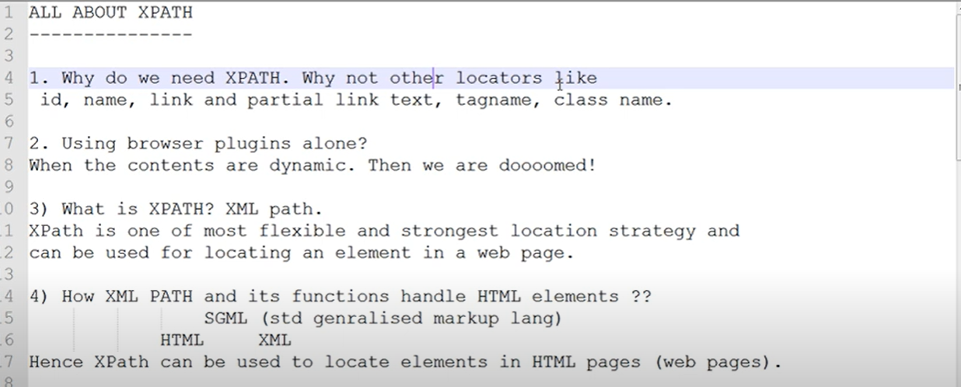

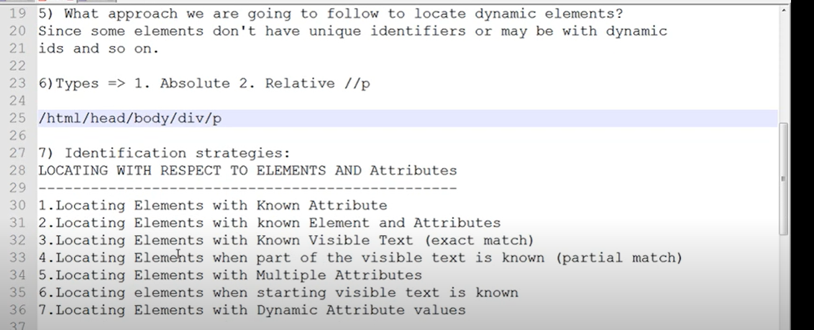

Known Attribute  
Known element and attributes

Known visible text (exact match)

Part of the visible text is known (partial match)

Multiple attributes

When starting of the visible text is known

Dynamic attribute values

The quality of good locator is to retrieve only one web Element

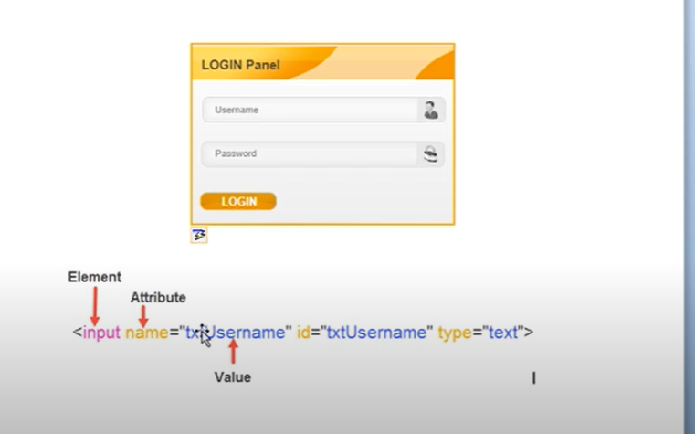

**1.Unknown Element and Known attribute**

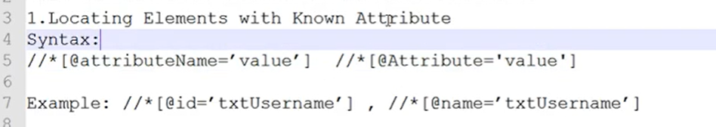

Hands on

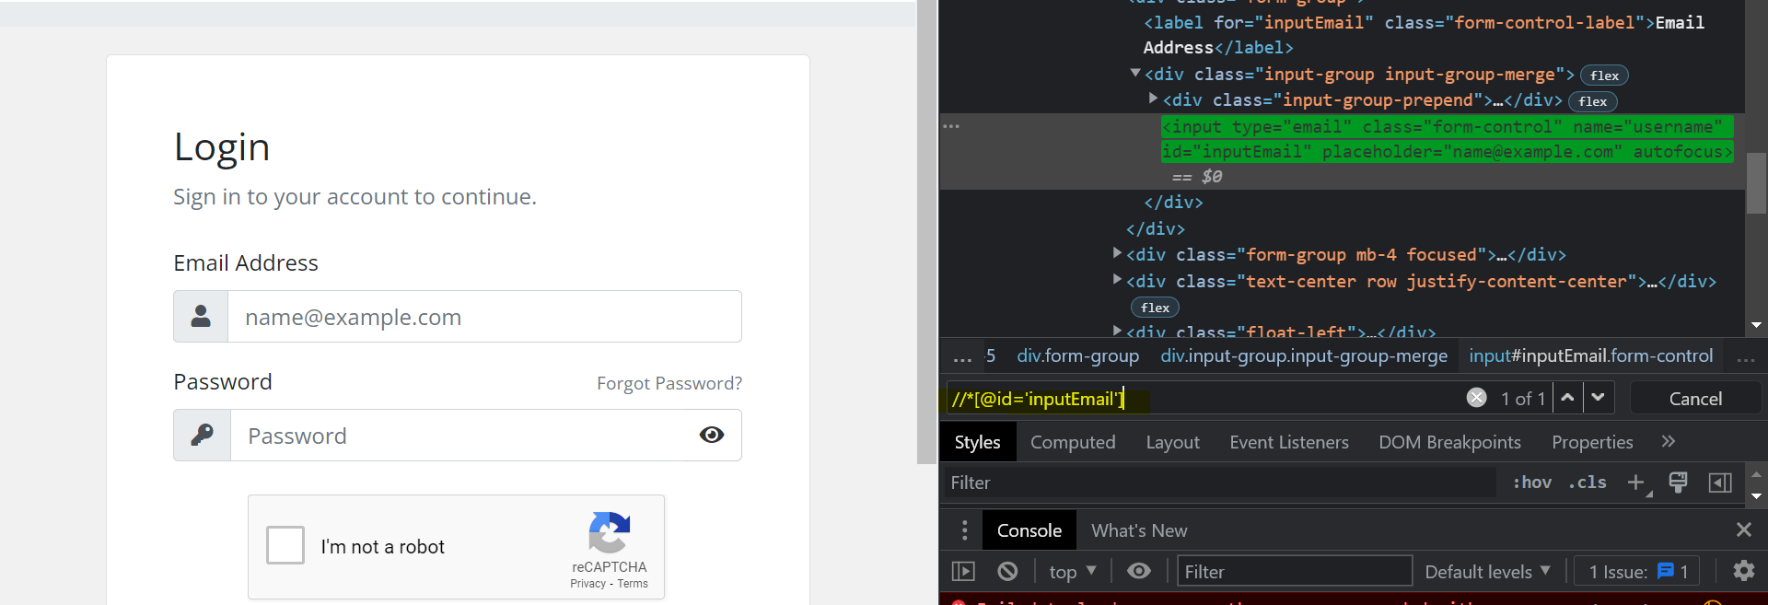

Trying with name

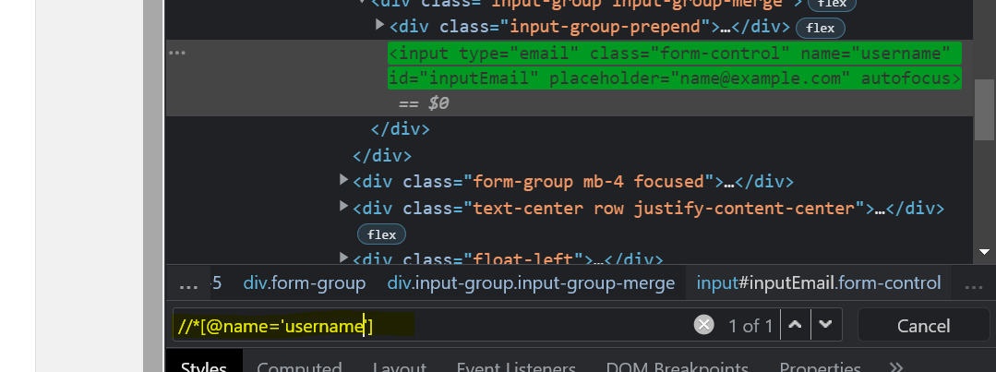

**2.Locating Element with known element and attribute**

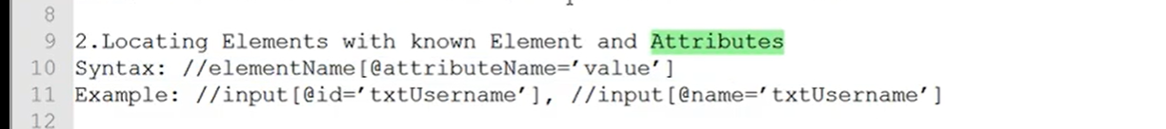

**Input Element**

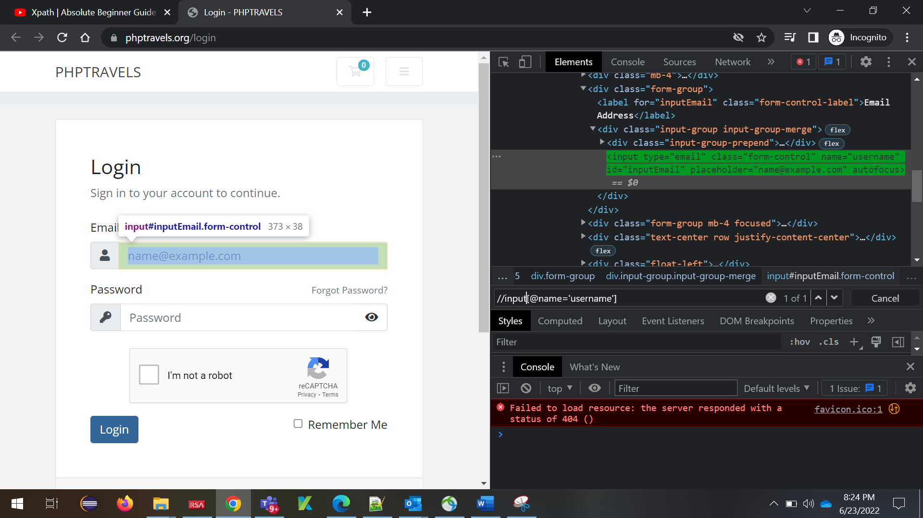

**Button Element**

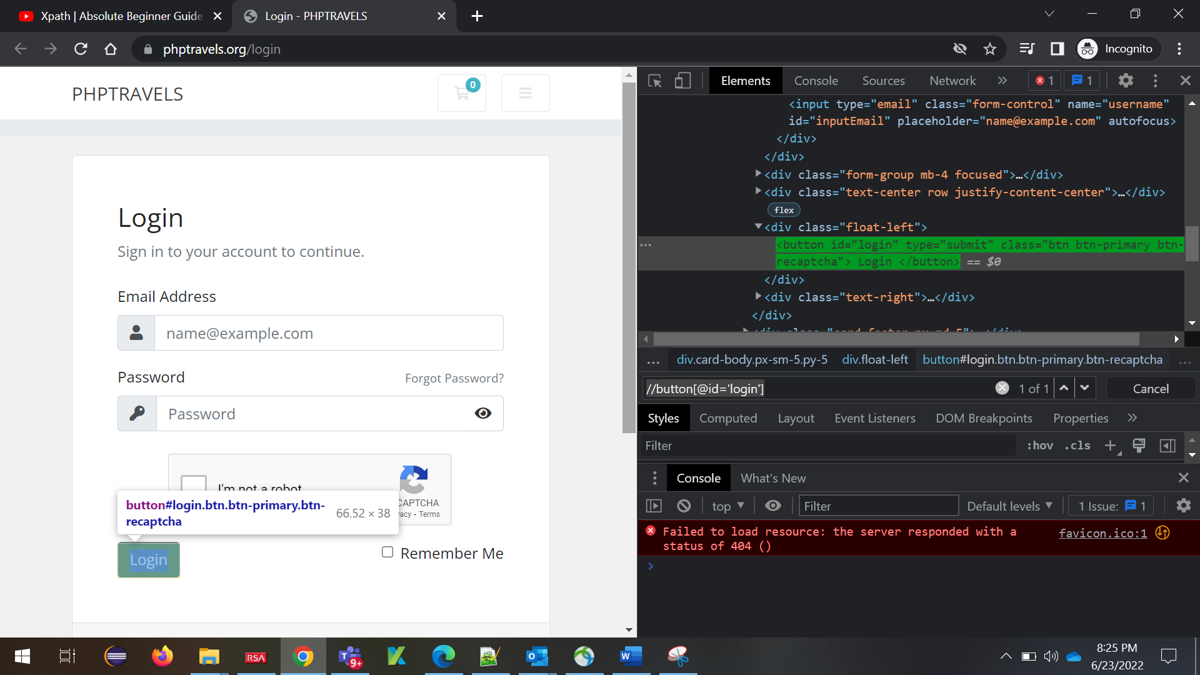

**3. Locating Elements with known visible Text (Exact Match)**

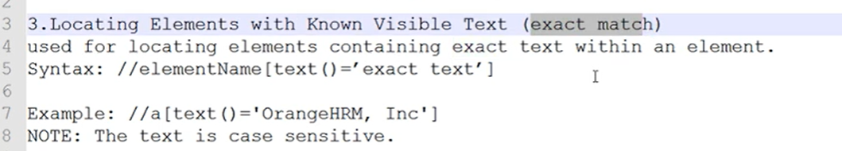

Hands ON

Used **text function to find the exact match** and used **normalize-space() function to exclude the spaces**

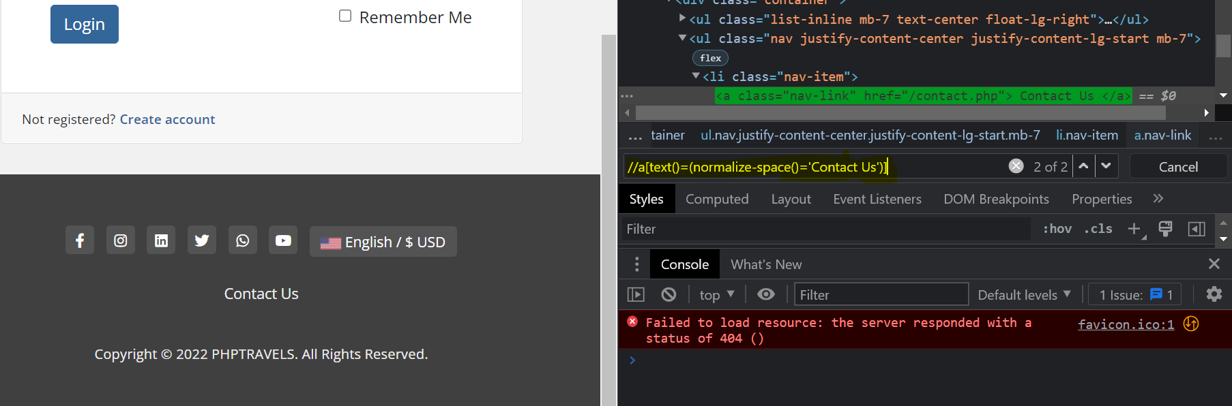

**4. Locating Elements with partial known visible Text (using contains )**



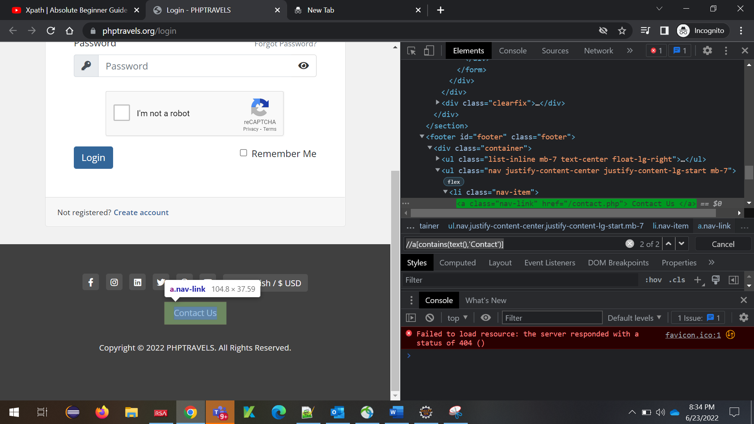

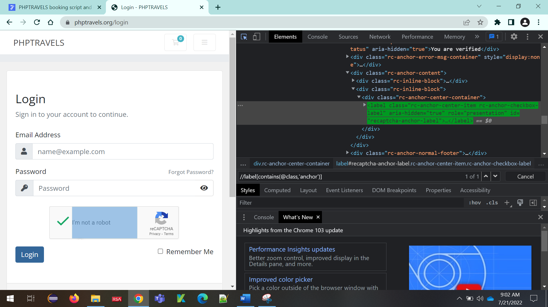

**5. Multiple Attributes**

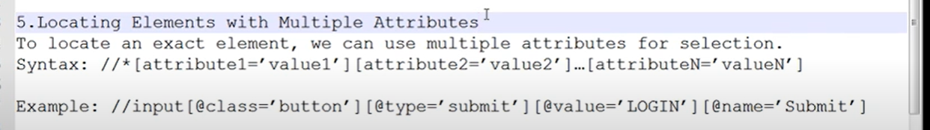

**Two attributes**

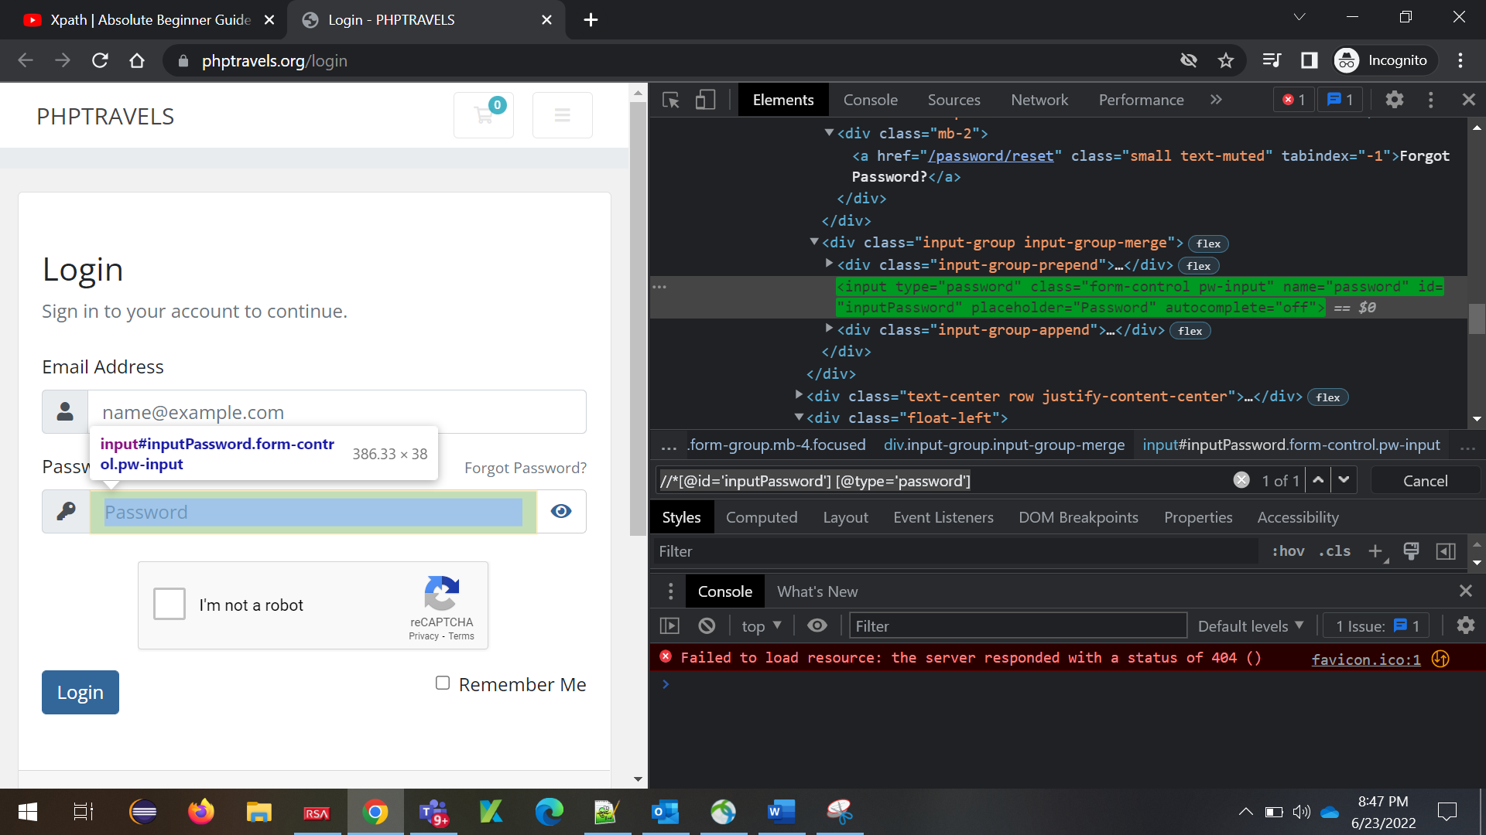

**Three attributes**

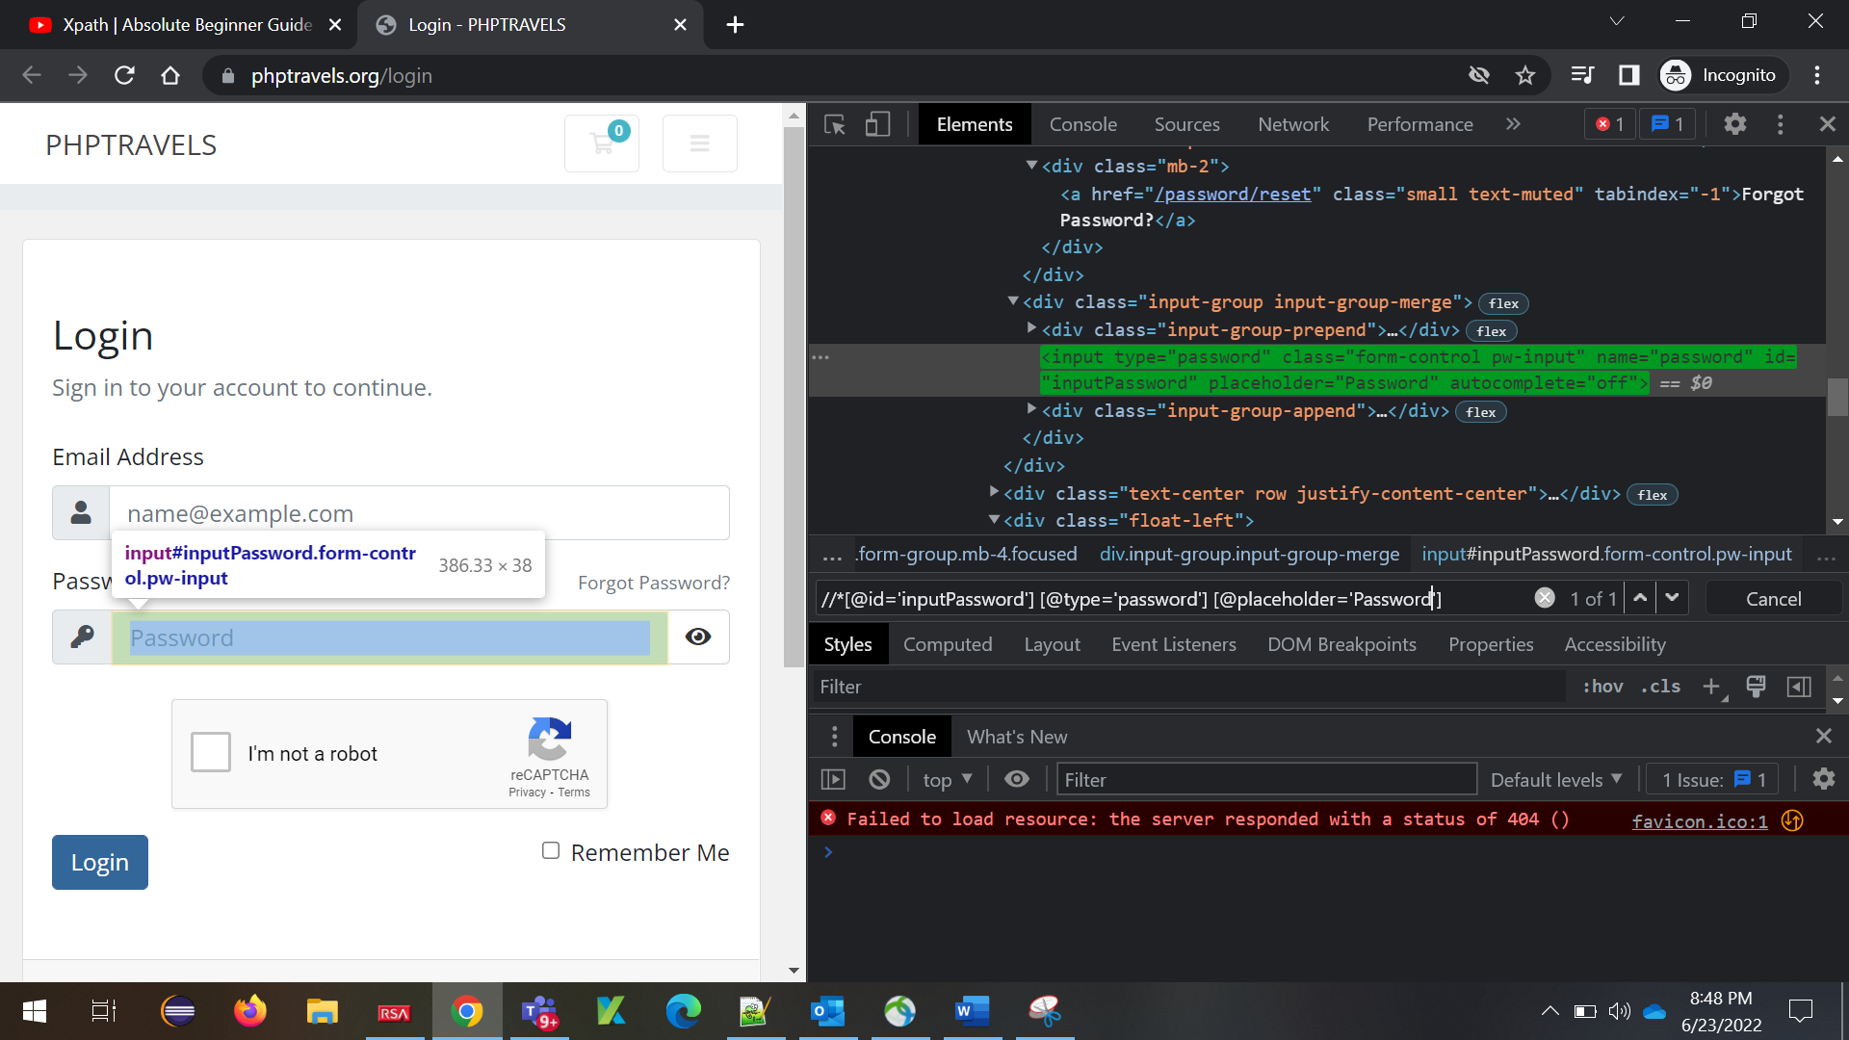

**6.STARTING VISIBLE TEXT**

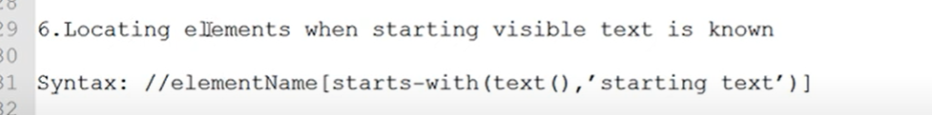

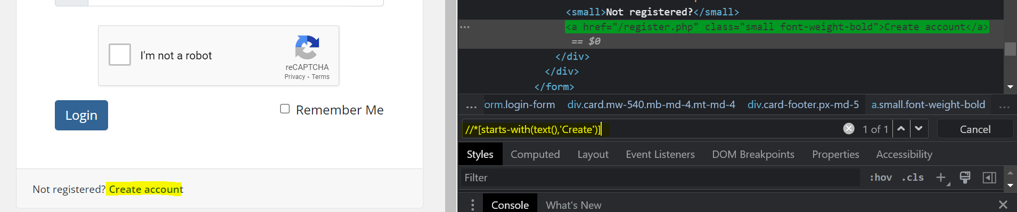

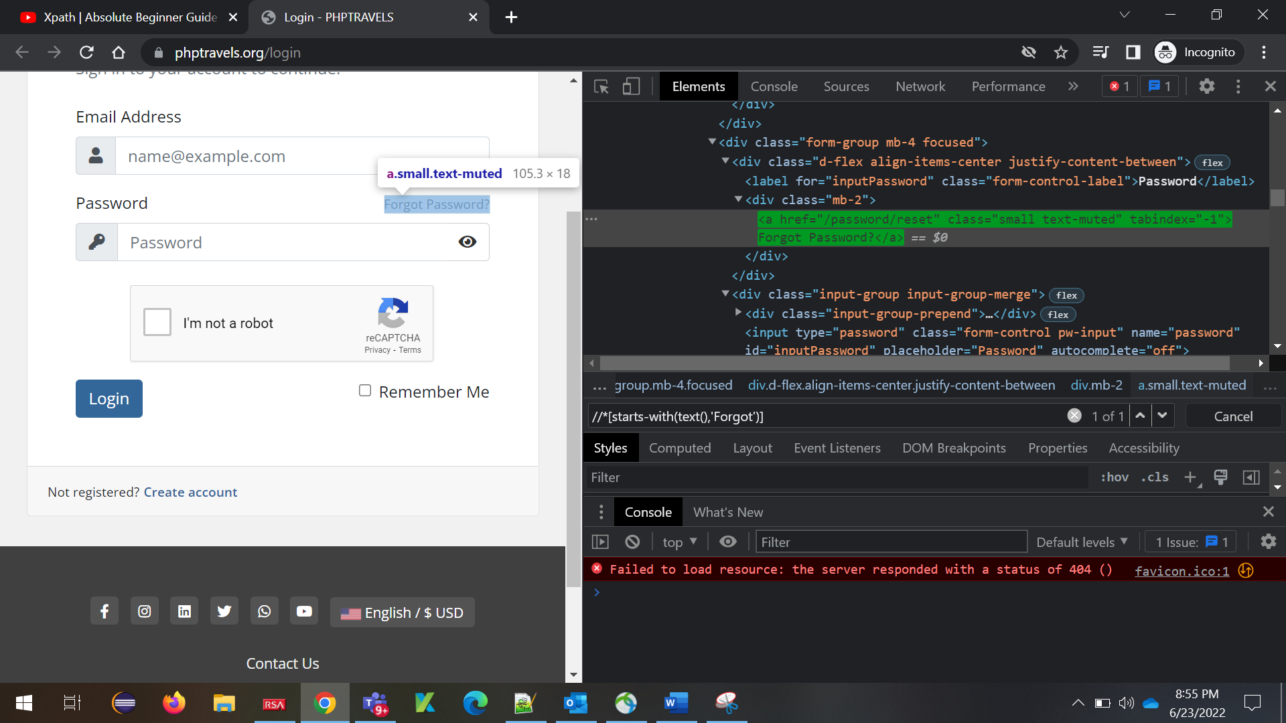

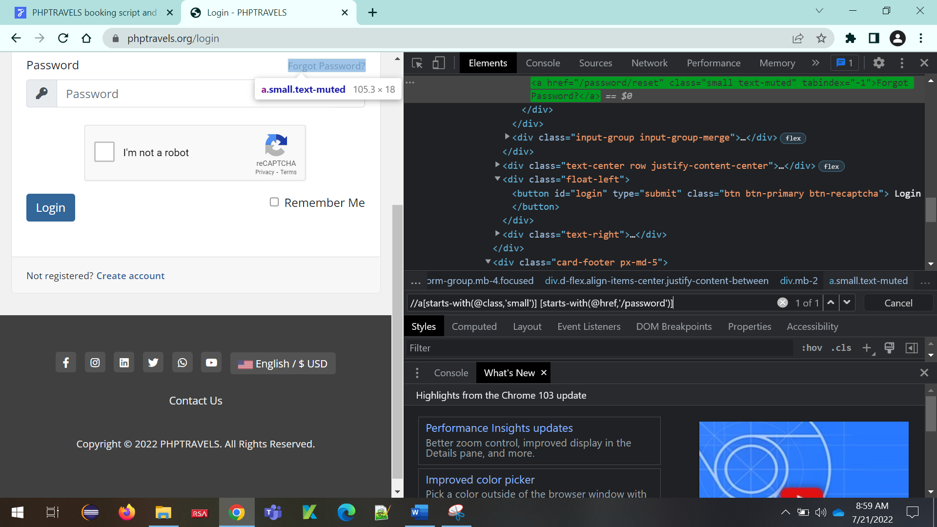

**7.Dynamic Attributes**

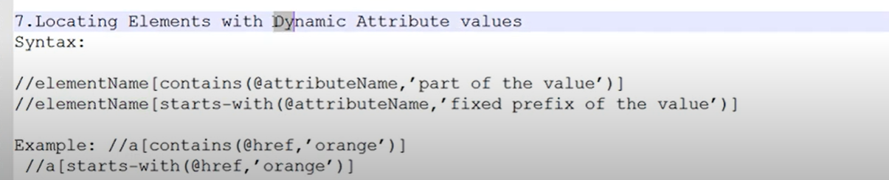

**Starts-with(@attributename,’value’)**

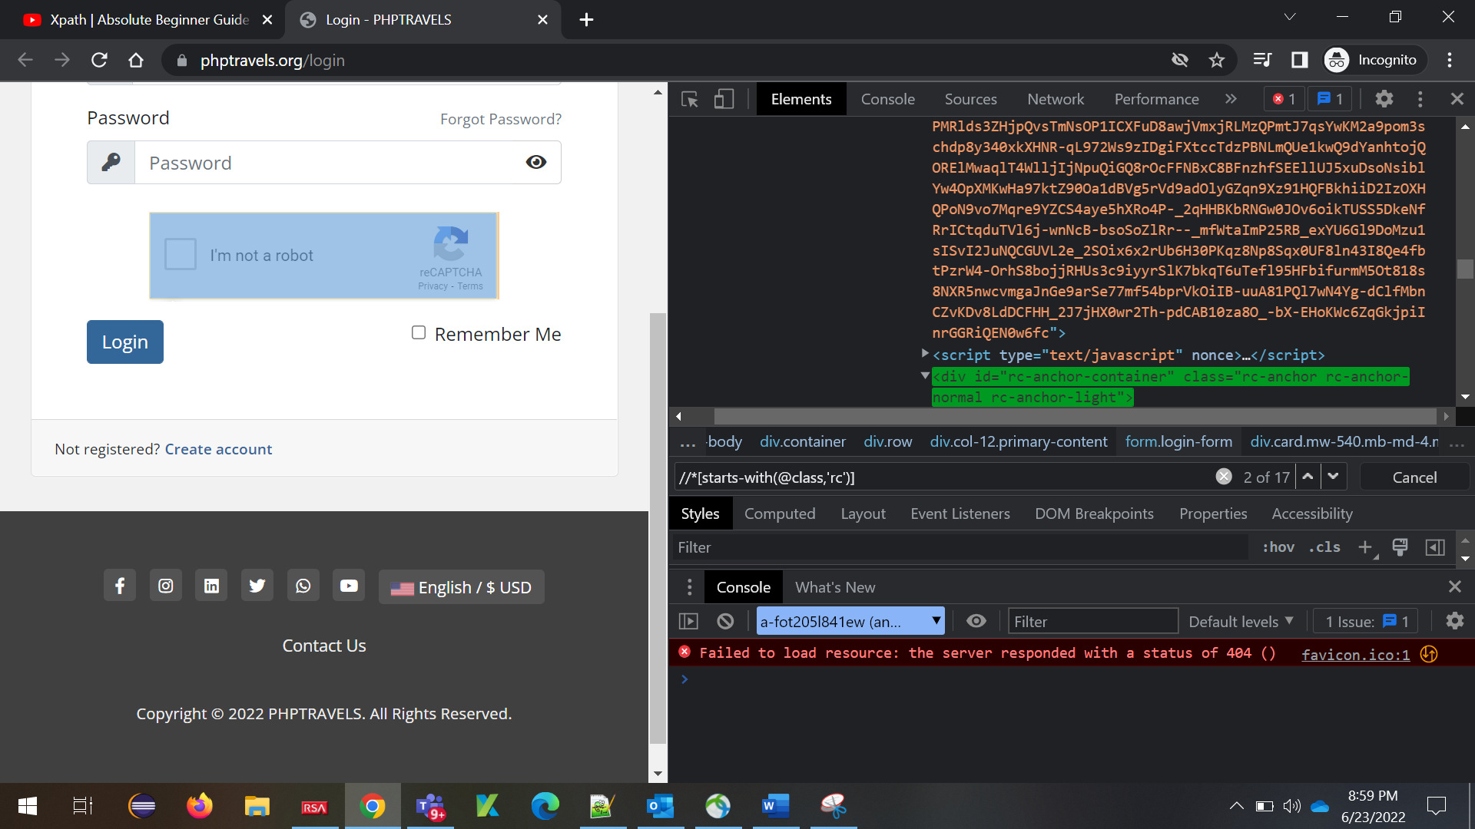

**Starts-with(@id,’value’)**

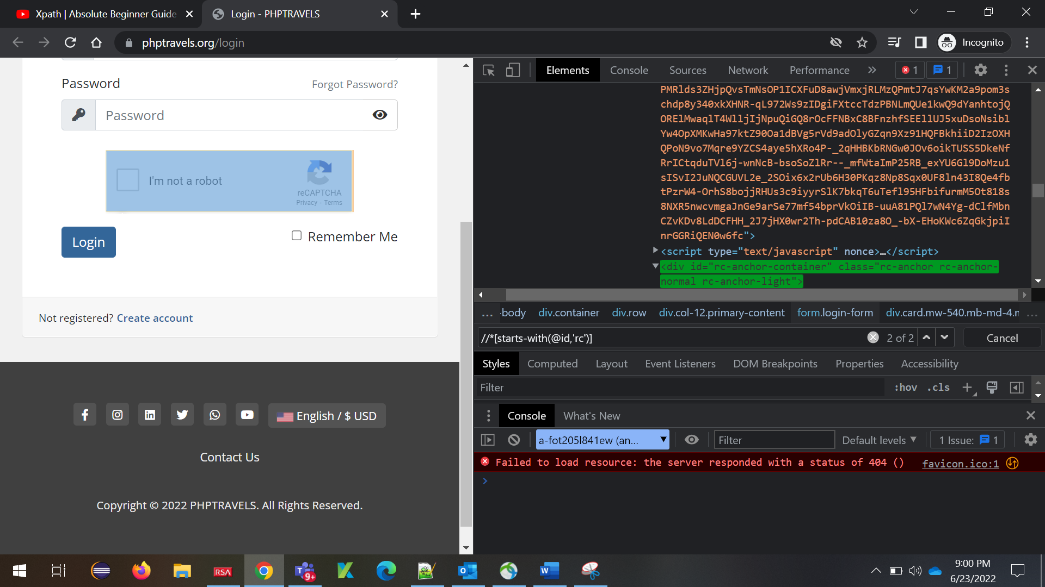

**contains(@id,’value’)**

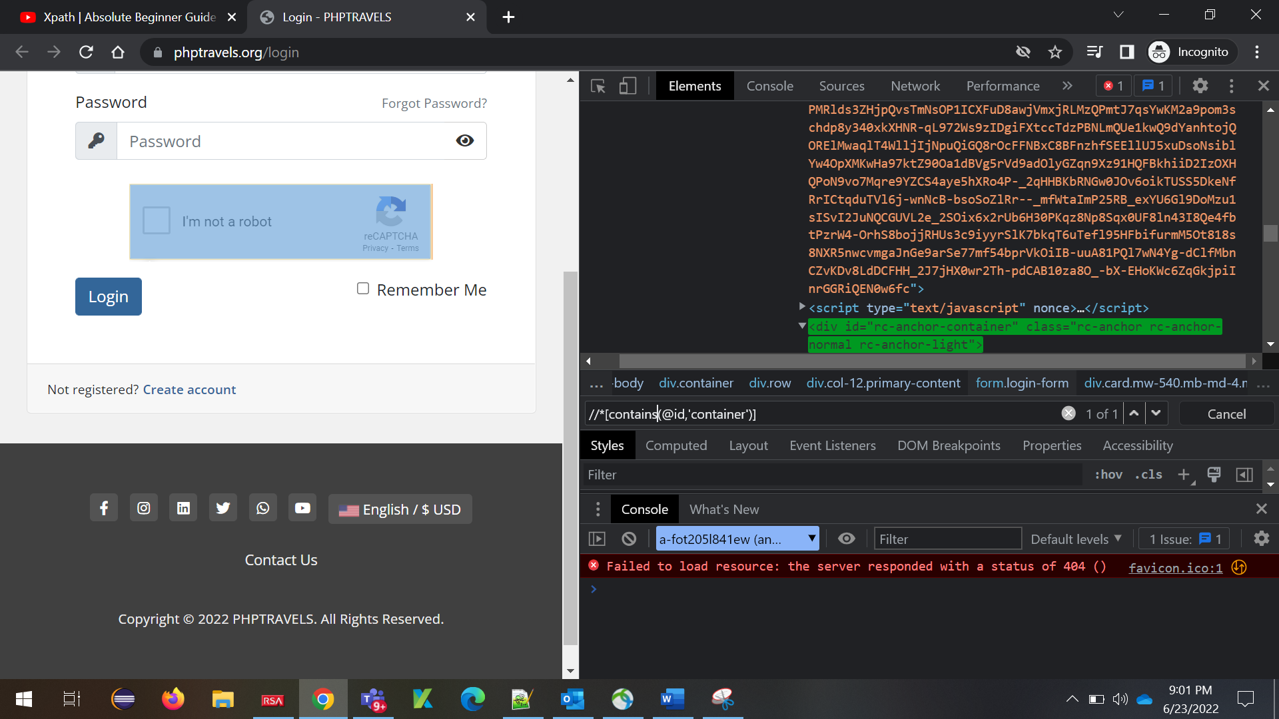

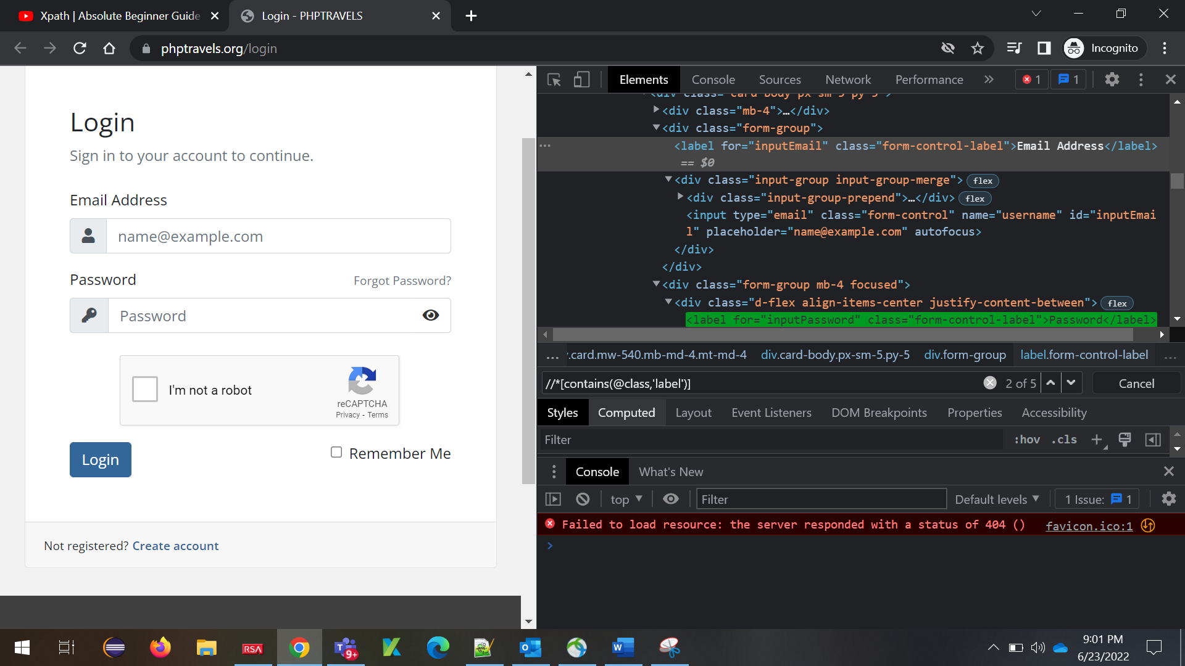

**8.Locating parent element**

**9.Locating child element**

**10.Locating ancestors of a known element**

**11.Locating following element**

**12.Locating preceding element**

**13.Locating following sibling**

**14.Locating preceding sibling**

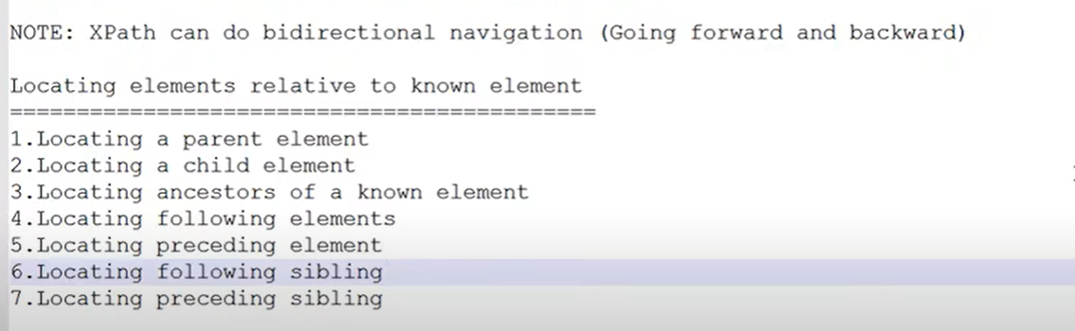

**8.Locating Parent Element**

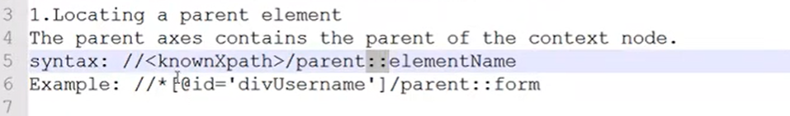

**If you know the parent element, then use element name**

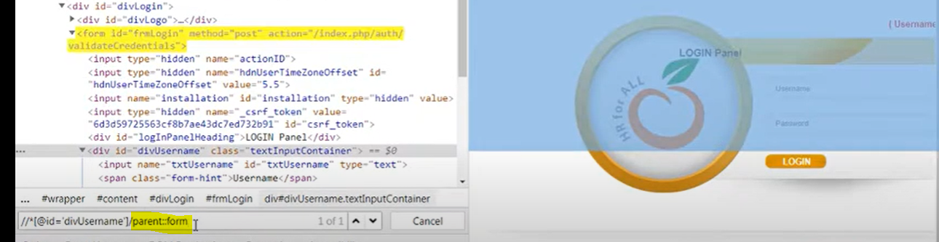

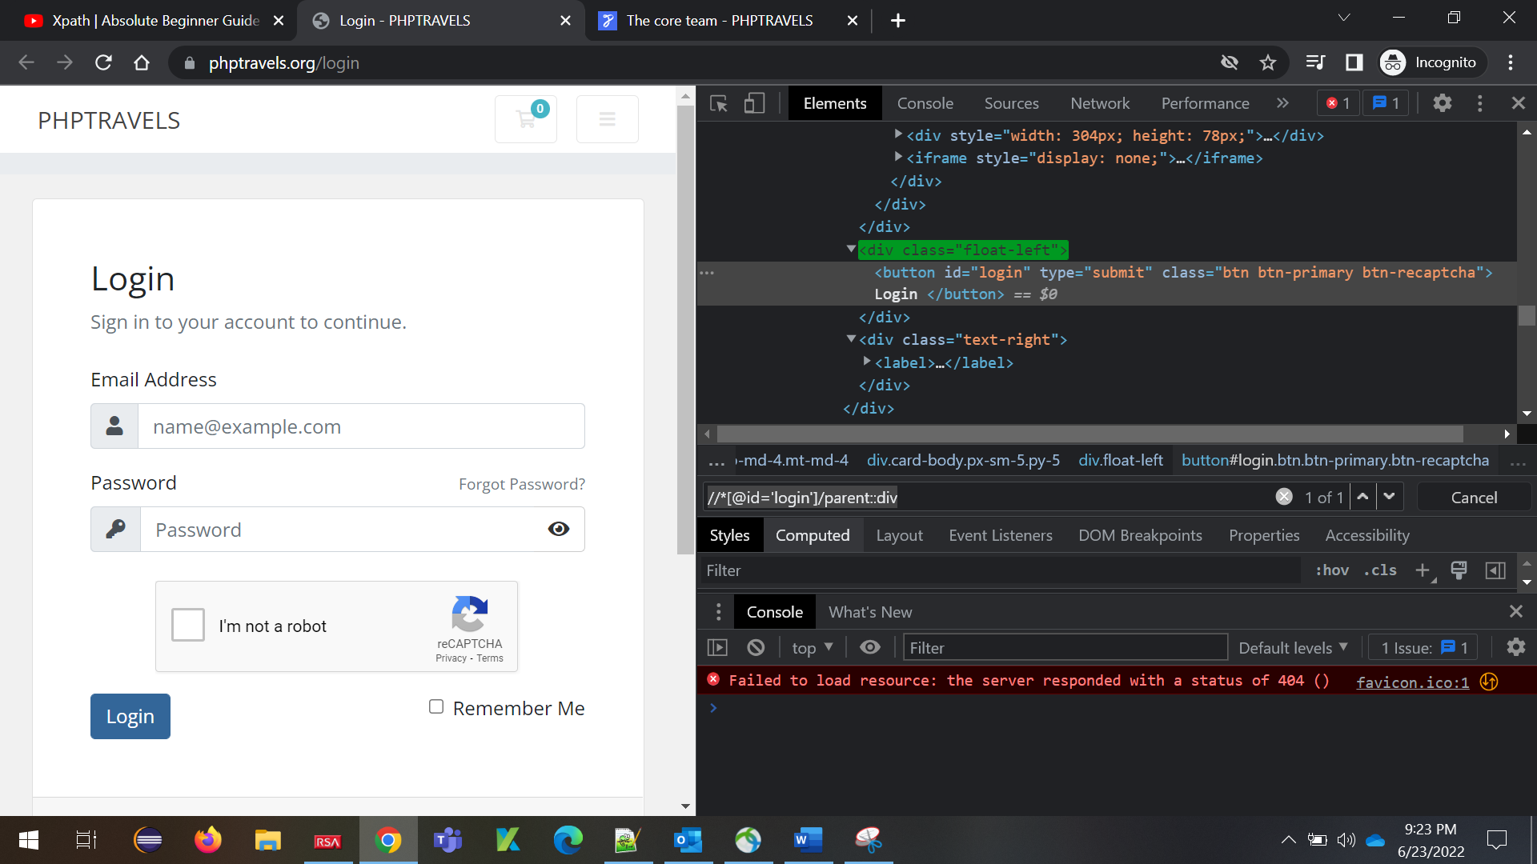

**If you don’t know the parent element, then use \***

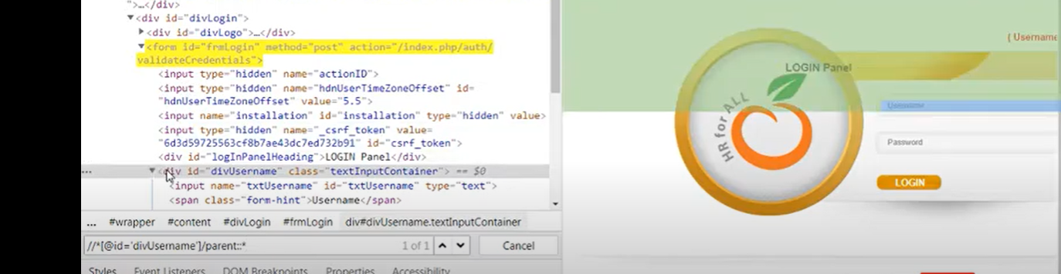

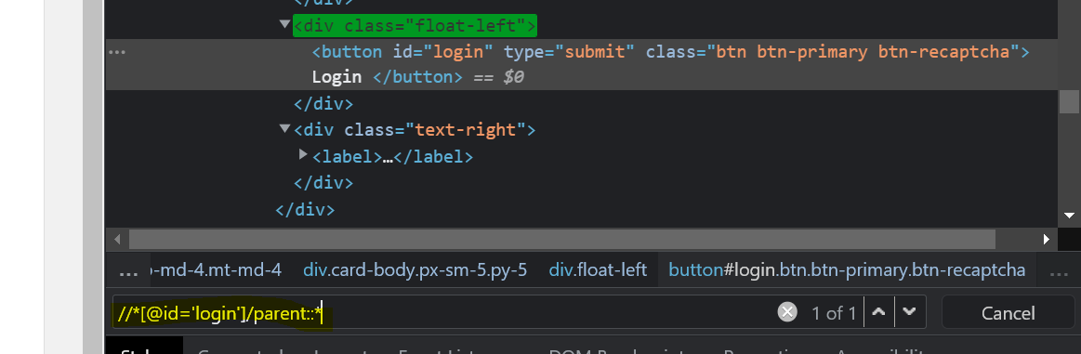

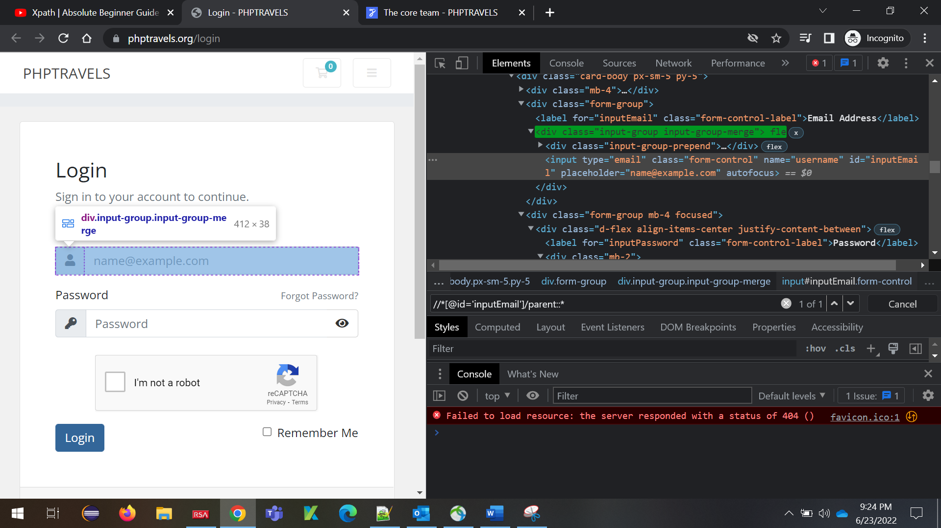

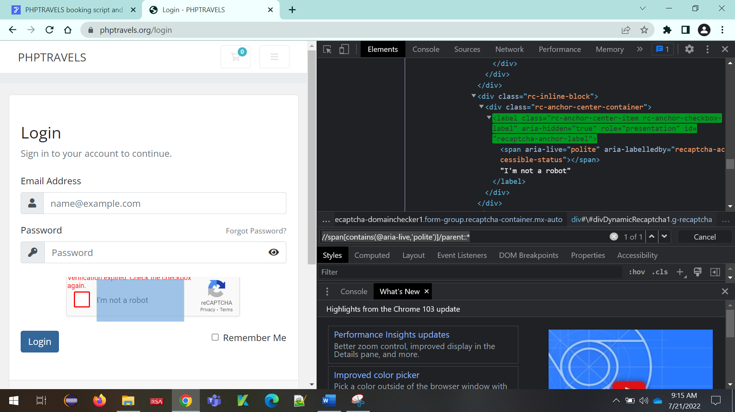

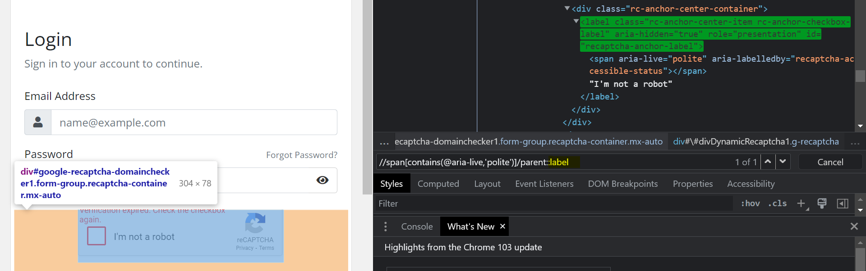

**9. Locating Child Element**

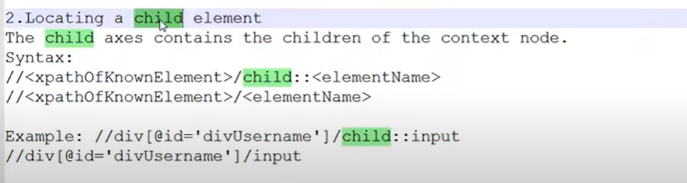

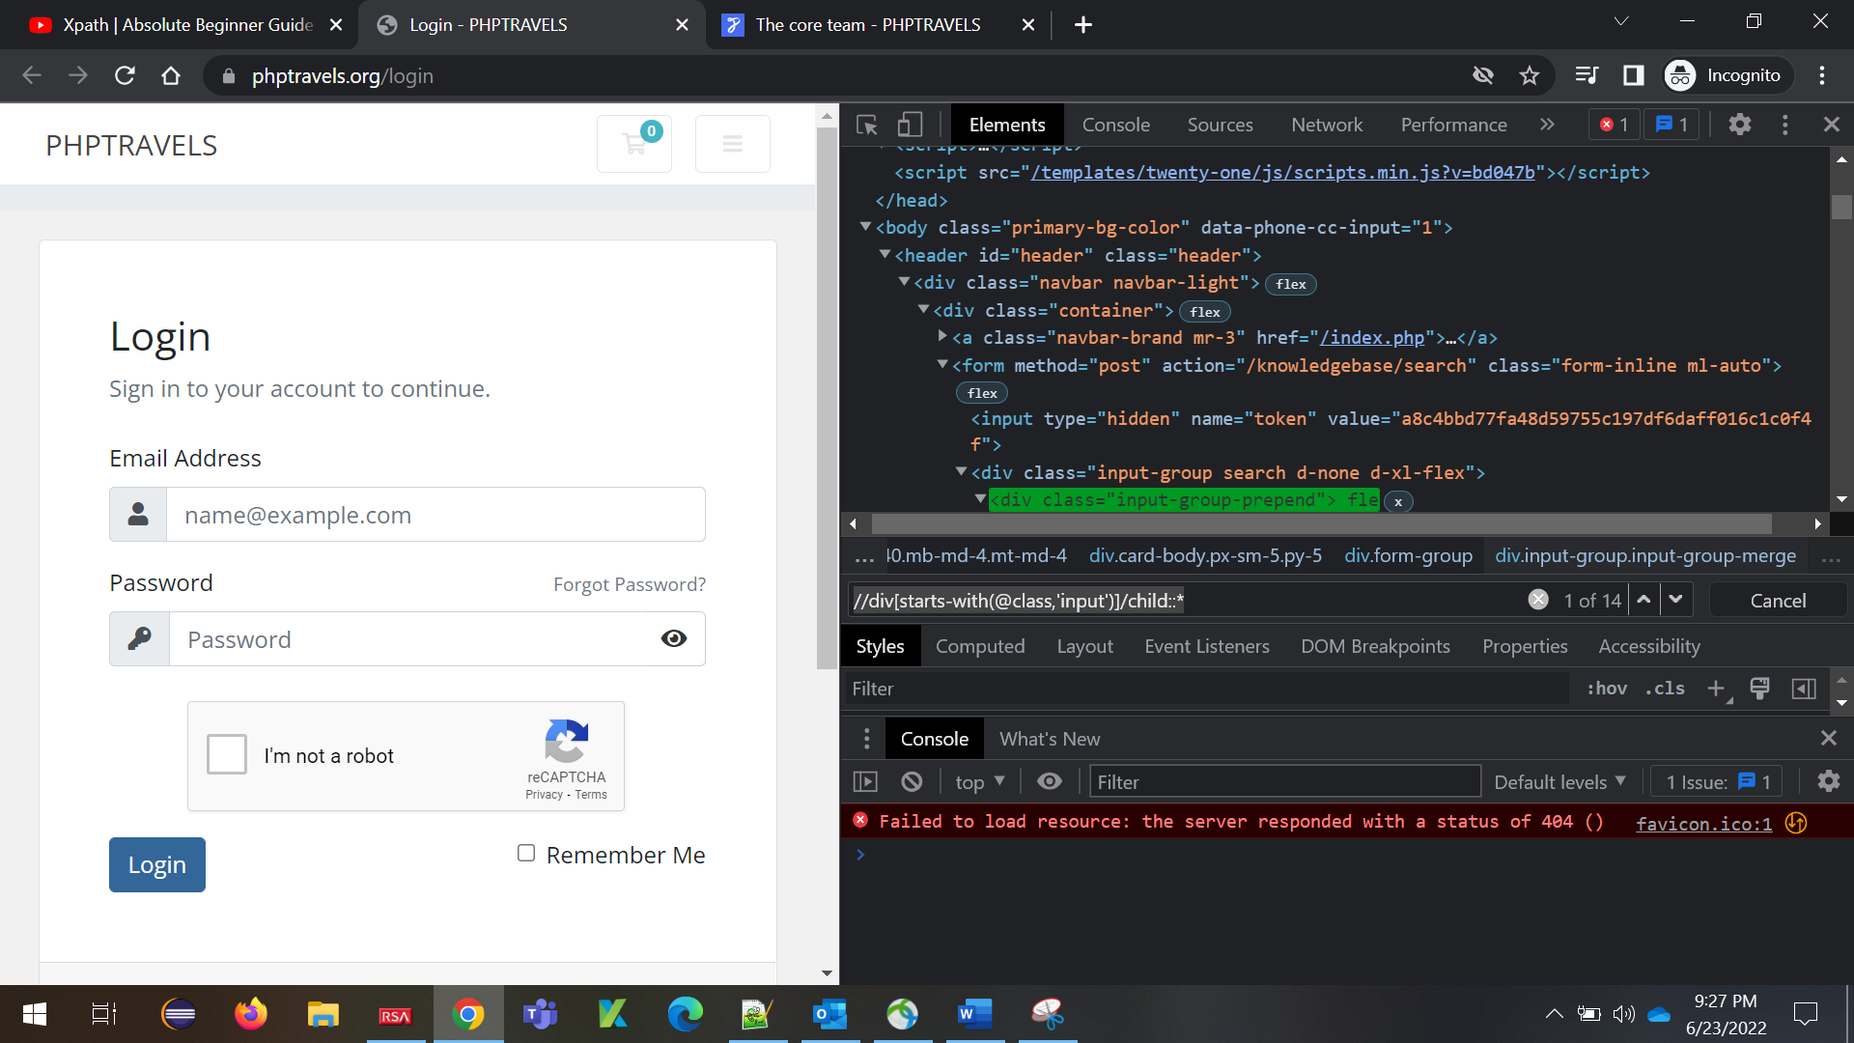

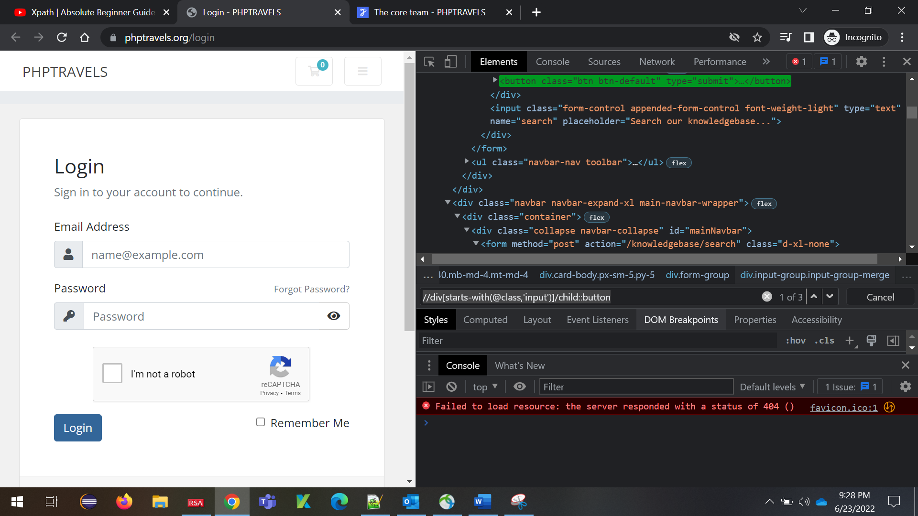

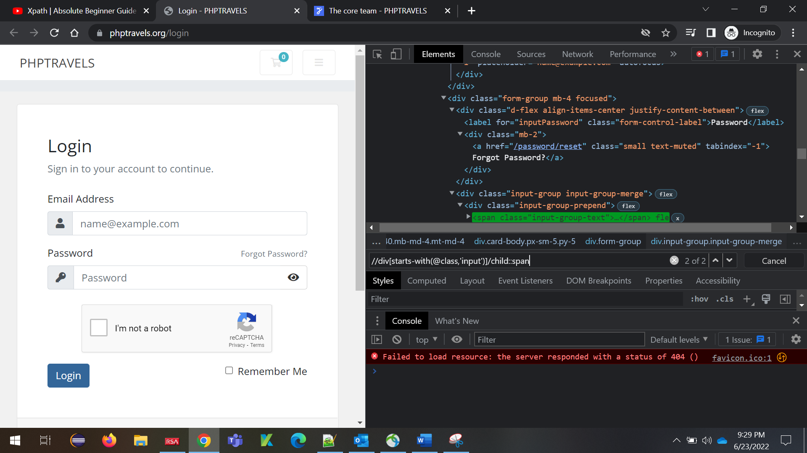

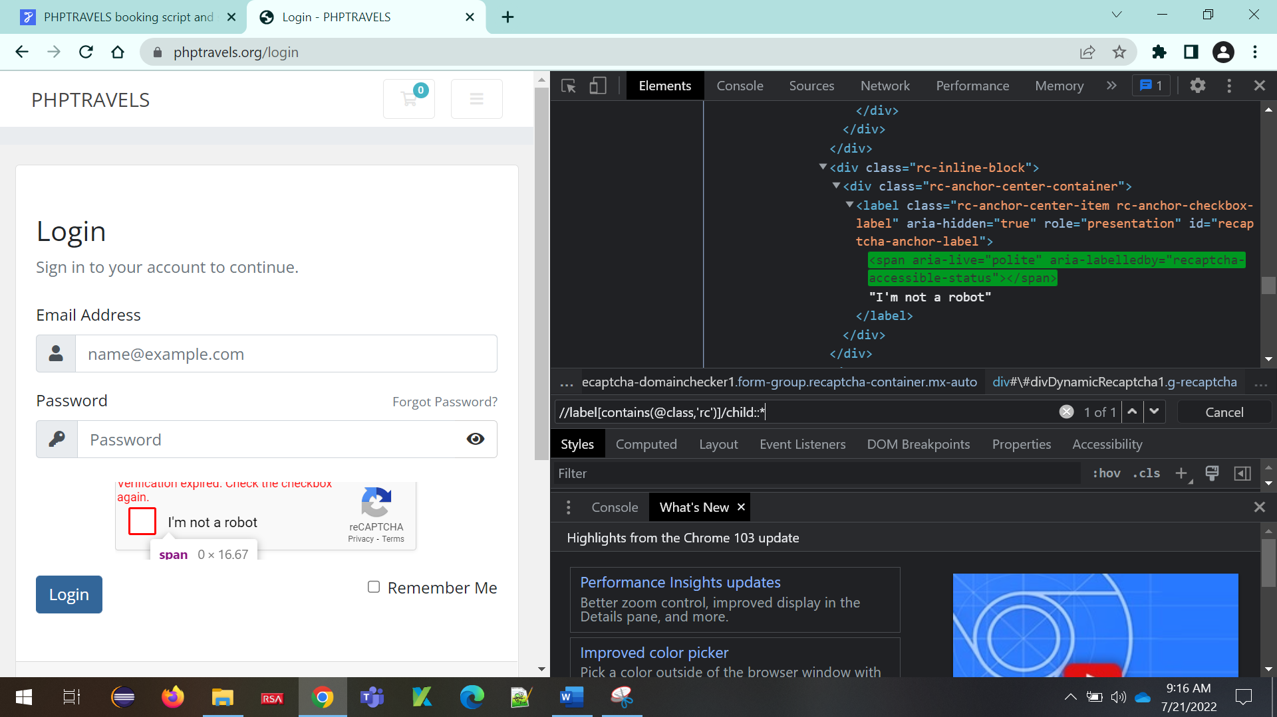

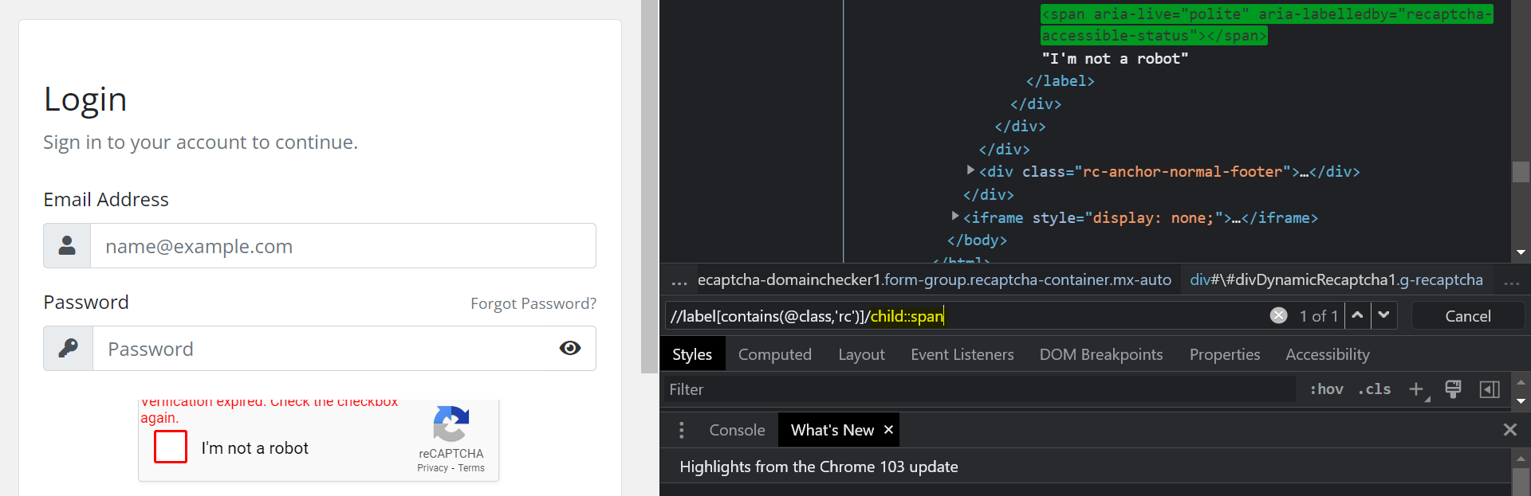

**10.Ancestor**

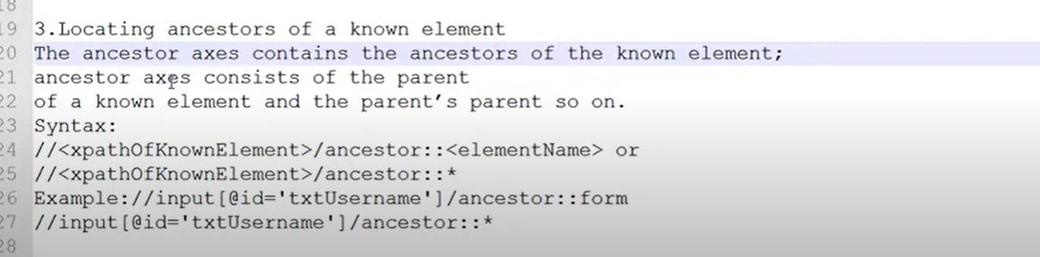

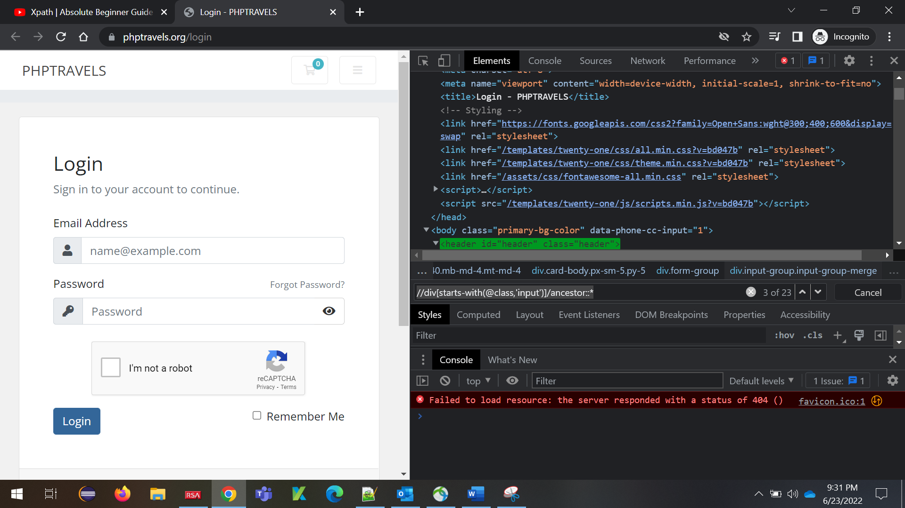

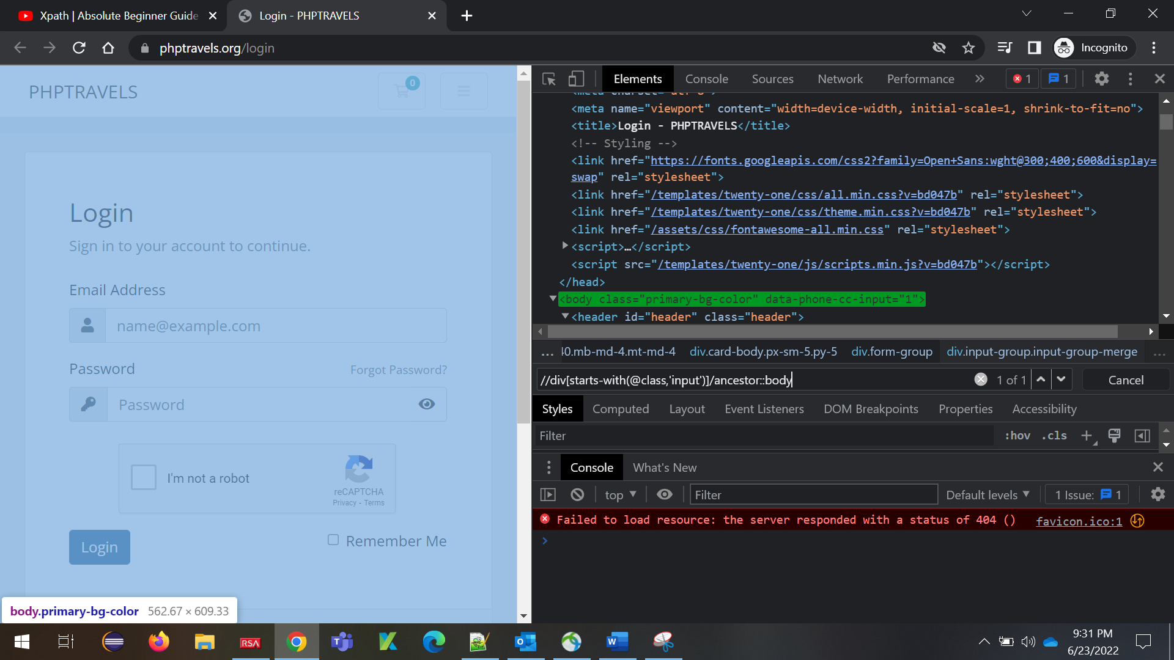

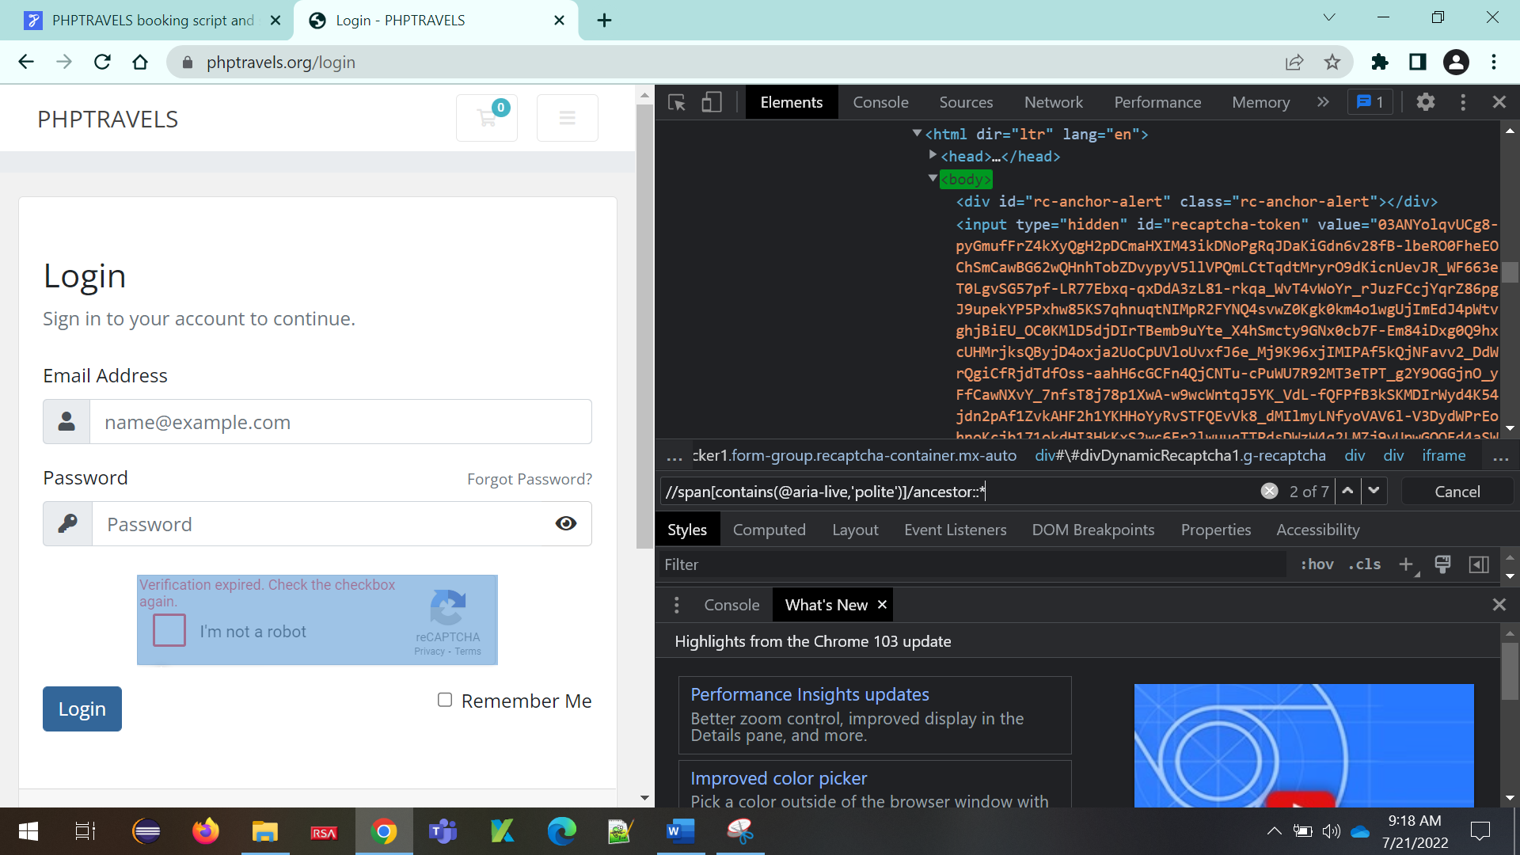

**11.Following Element**

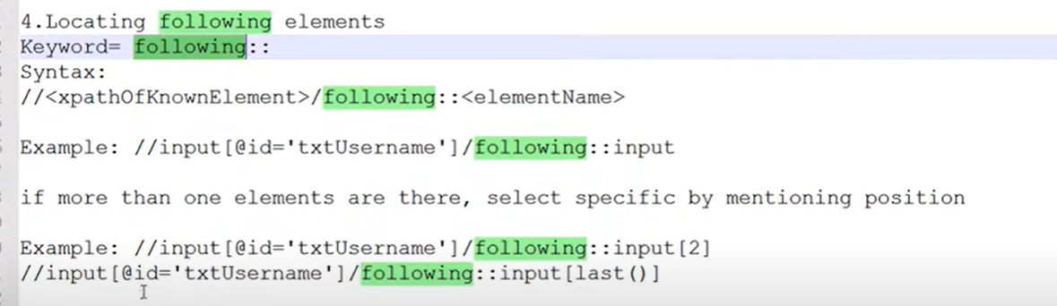

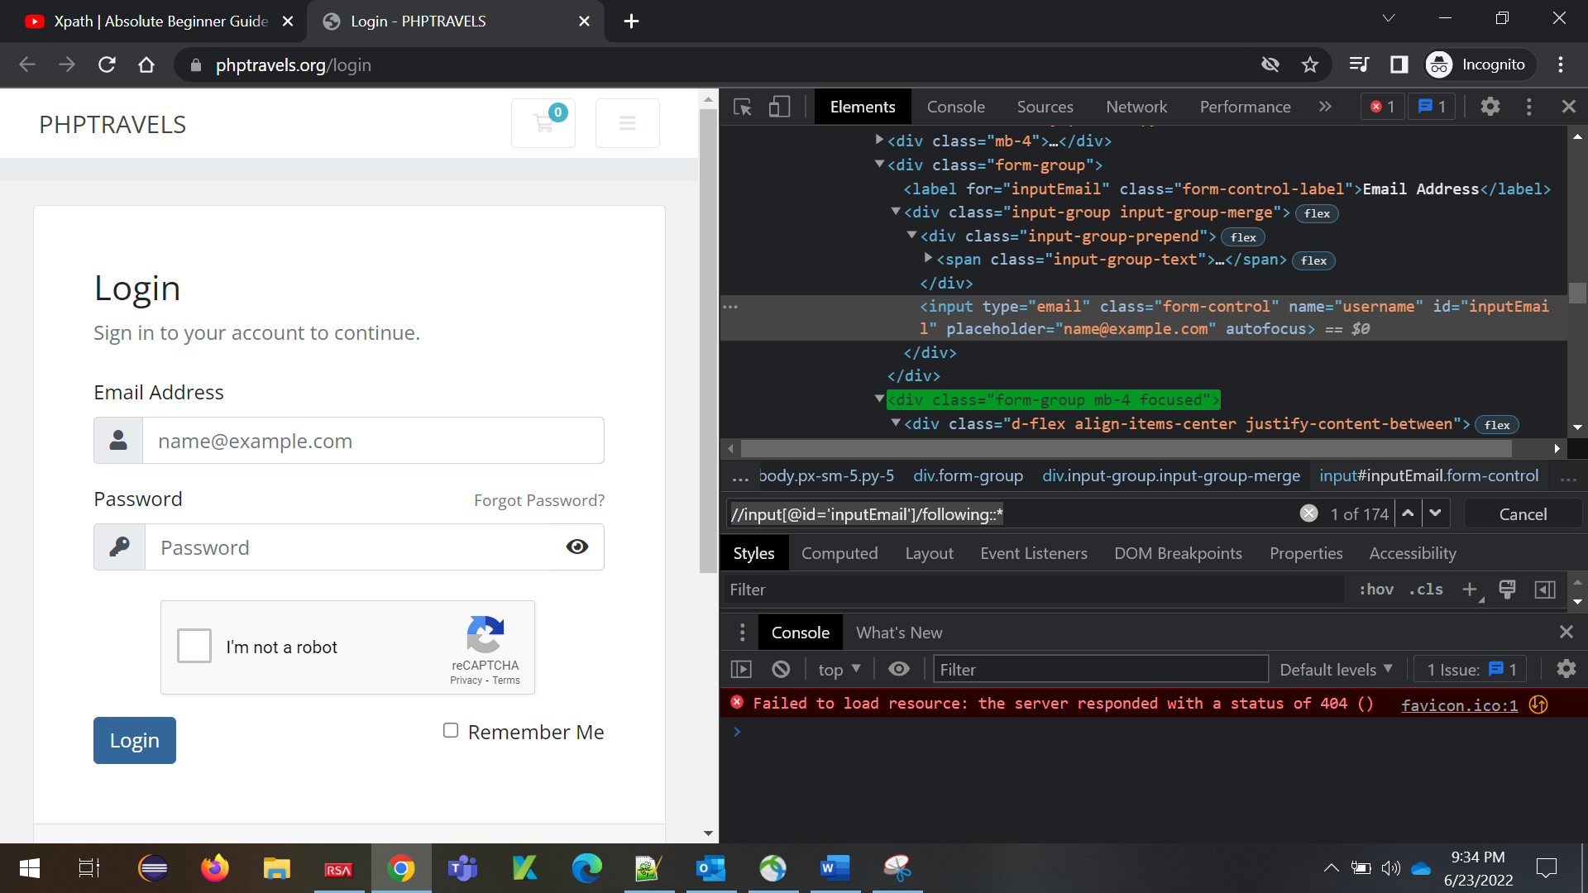

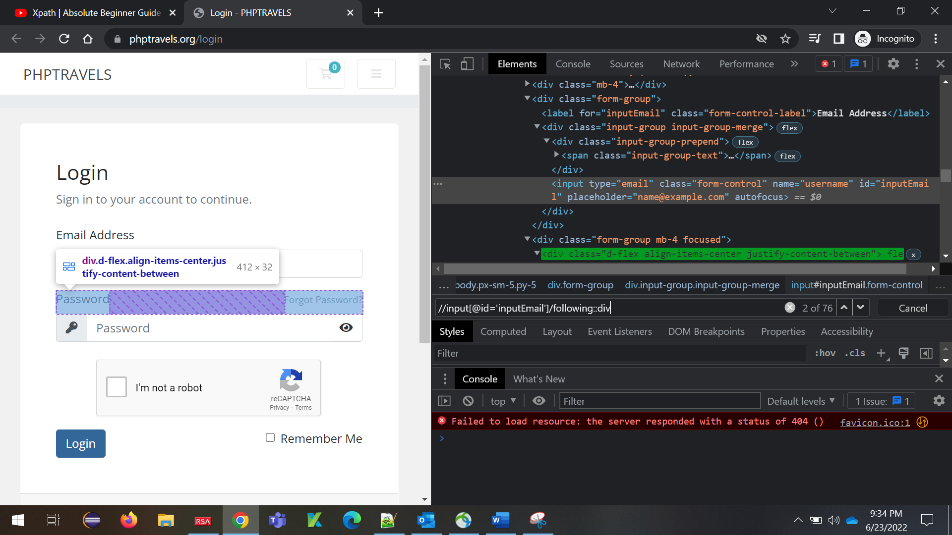

**12.Preceding Element**

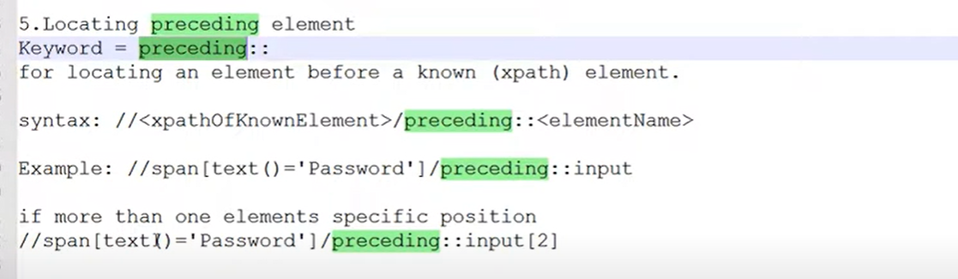

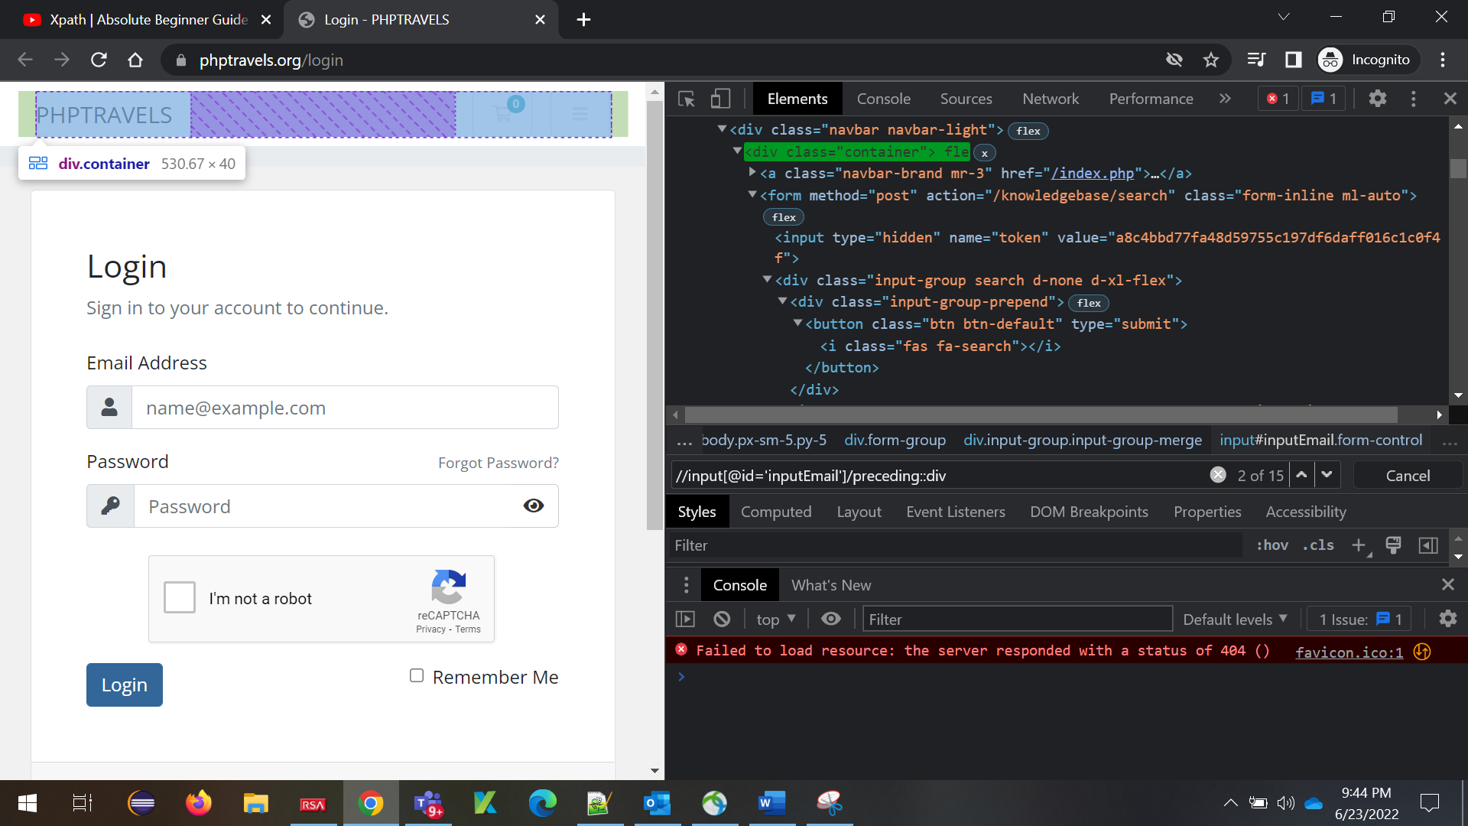

**13.Following-sibling**

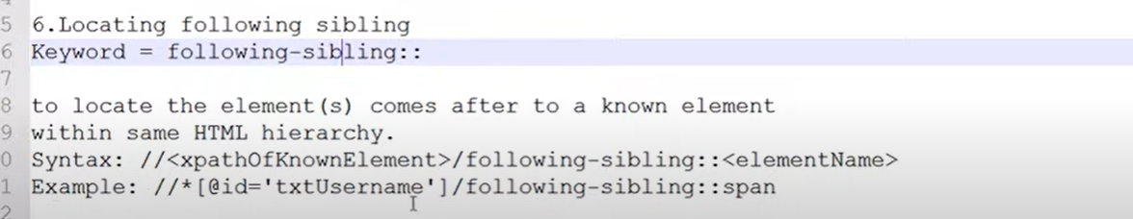

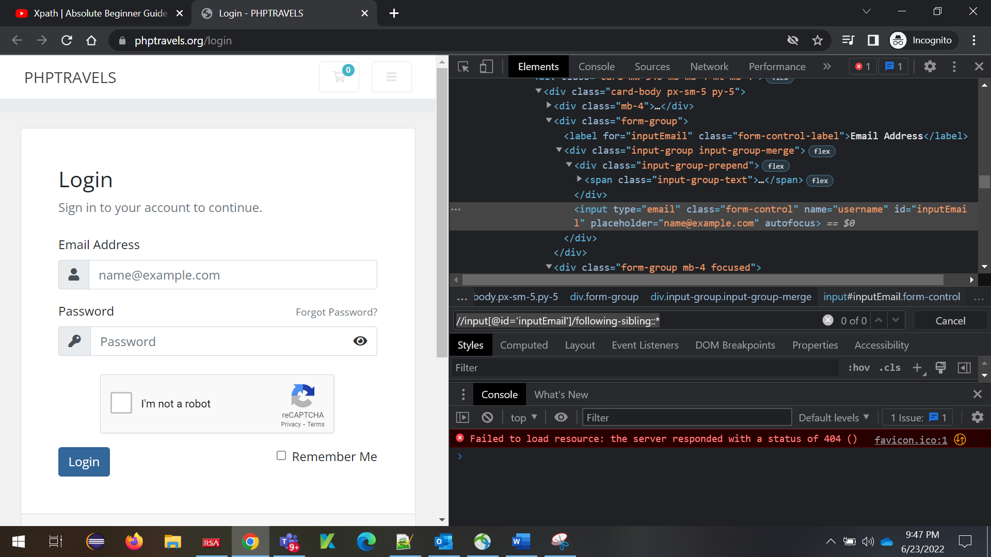

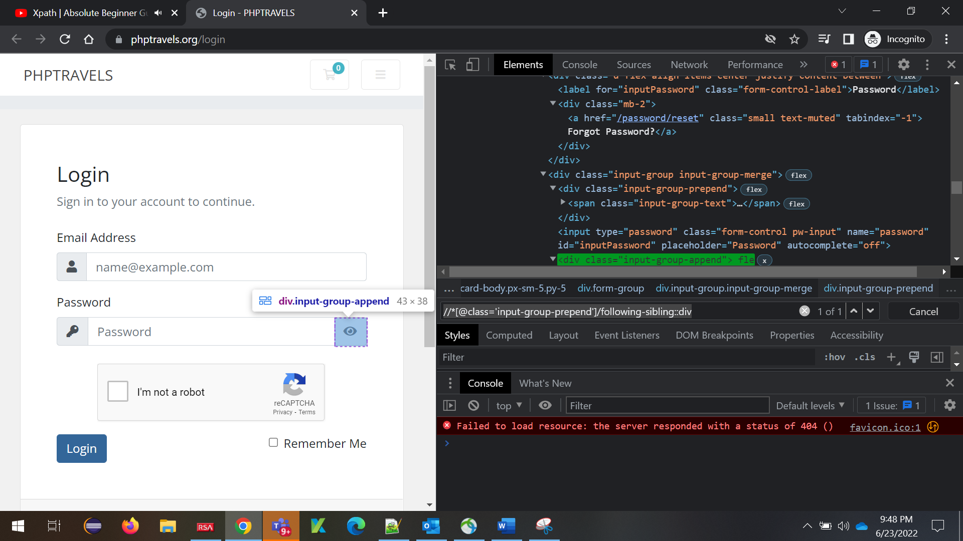

**14.Preceding-sibling**

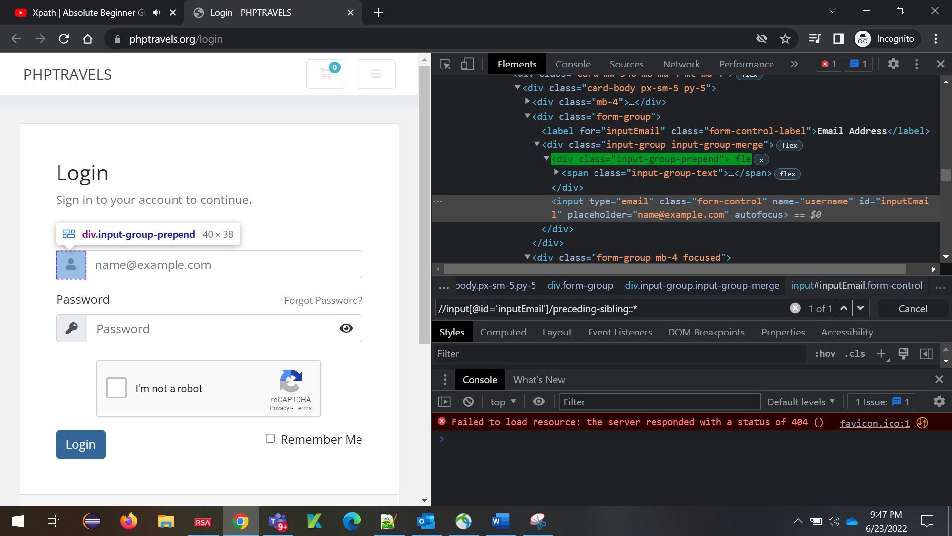

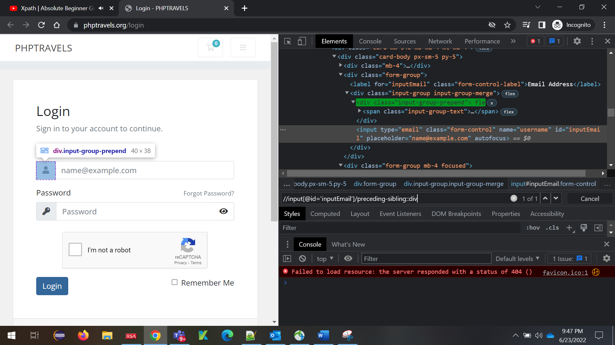

**ADVANCE CONCEPTS**

**1.Use and operator when we need to use multiple attributes**

//*[@id=’’ and @value=’’]

**2.Google Search button XPATH**

(//div[@class='FPdoLc lJ9FBc']//following-sibling::*)[2]

//div[@class='FPdoLc lJ9FBc']//input[@value='Google Search']

**3.Amazon Book search XPATH**

**Xpath for Book🡪**

//span[text()='The One Minute Manager']

**Xpath for Paper back🡪**

//span[text()='The One Minute Manager']//following::a[text()='Paperback'][1]

**4.Rediff BSE**

//a[normalize-space()='ITC Ltd.']//following::td[5]//font[@class='red']

//a[normalize-space()='UltraTech Cement Ltd.']//following::td[3]